NAME: SYUHANA BINTI RAMLI

MATRIC NUMBER: 2017956923

CLASS: M3CS2453A

LAB 1 : INTRODUCTION TO ITT450 LABORATORY & KALI

1. ls

* The ls command lists contents of a directory

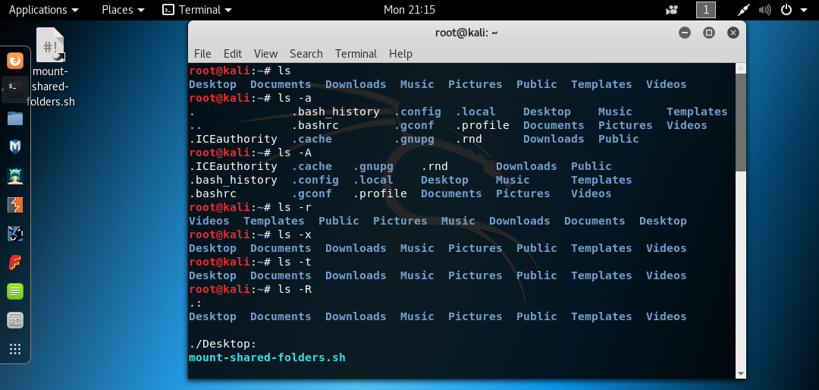

1. ls -a

* list all hidden files/directories (including hidden ones - those with names beginning with a dot '.')

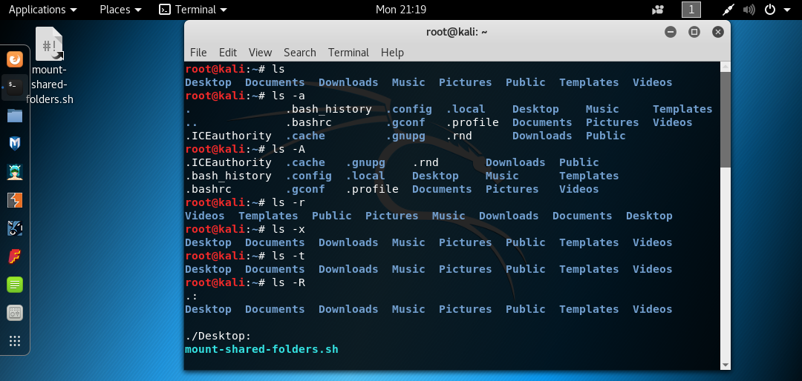

1. ls -A

* do not want to display / skip current (.) and previous directory (..) entries in output

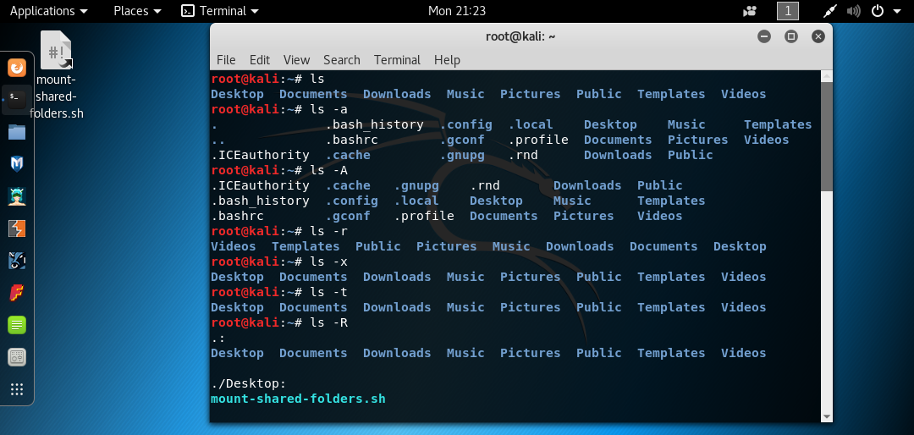

1. ls -R

* display contents of subdirectories

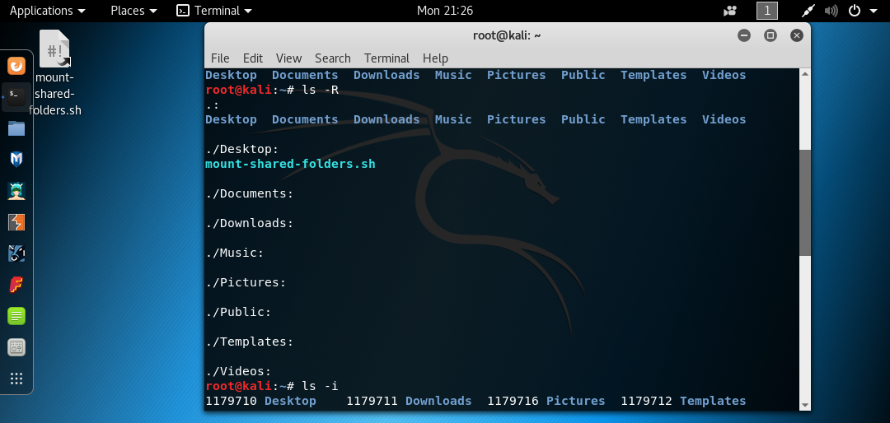

1. ls -i

* list file/directory names along with their respective inode numbers

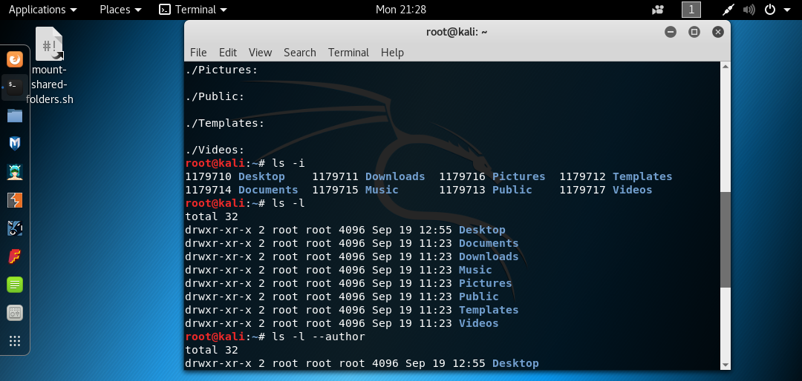

1. Cd

* Change user’s present working directory.

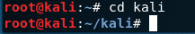

1. Mv

* rename a file/folder

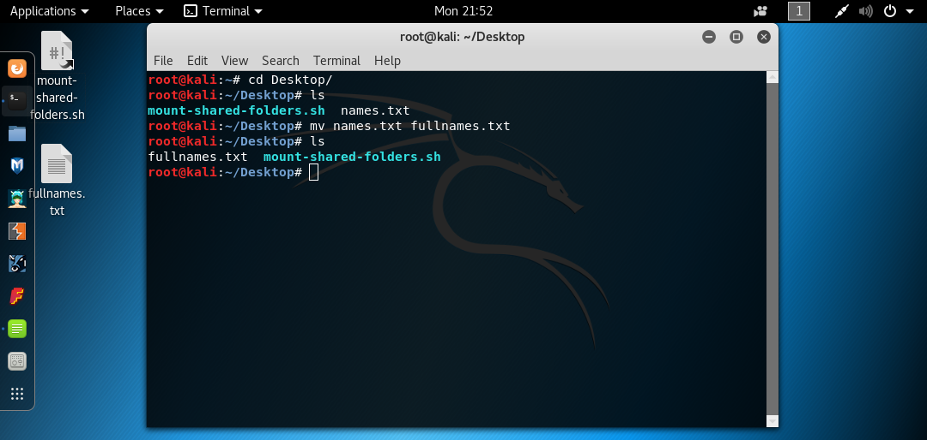

1. Rm

* To remove file

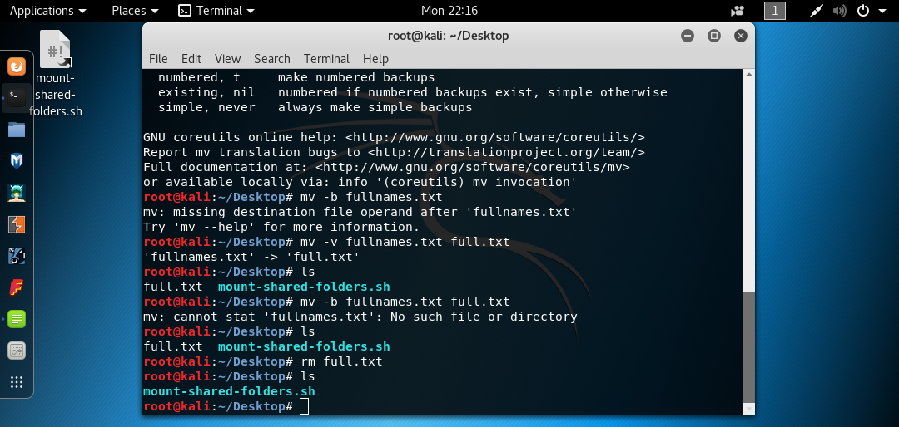

1. Rm -f

* Deleting a non-existent file or directory and will show the error/notifications. To make rm suppress such error/notifications use this command.

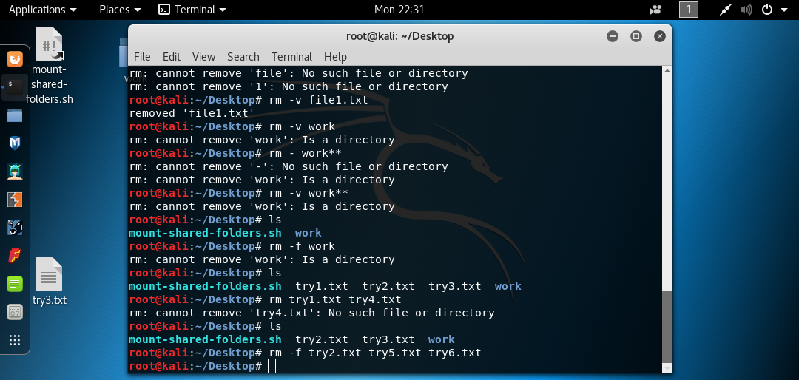

1. Mkdir

* Create directories

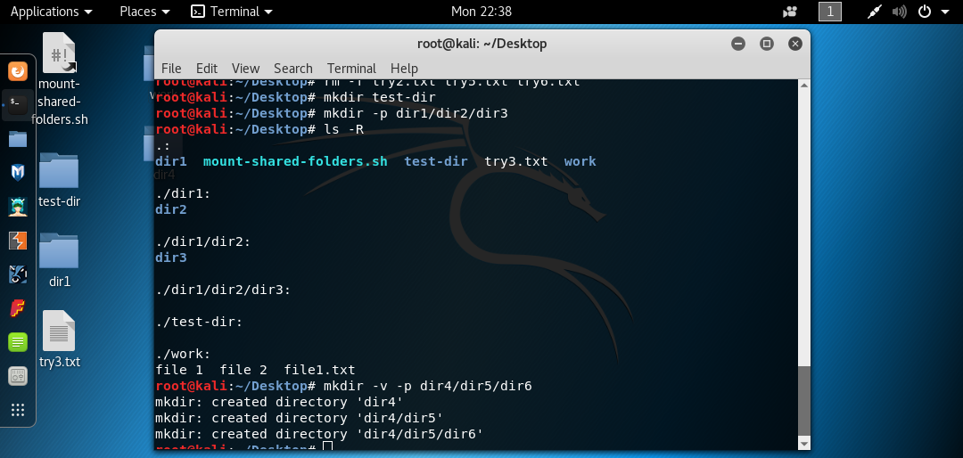

1. Mkdir -p dir1/dir2/dir3

* To make sure parent directories (if non-existent) are created in process

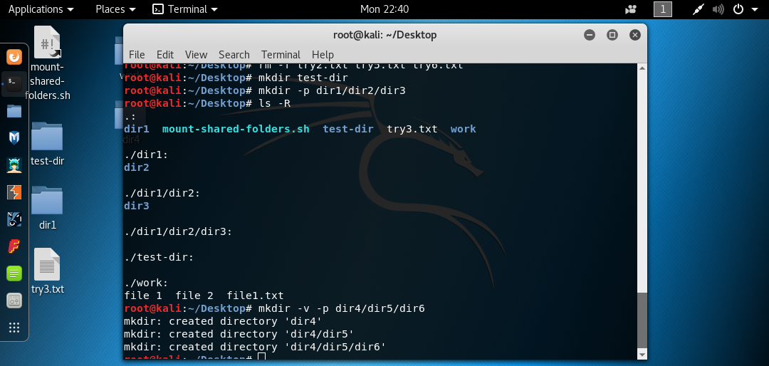

1. Mkdir -v -p dir4/dir5/dir6

* To make mkdir emit details of operation

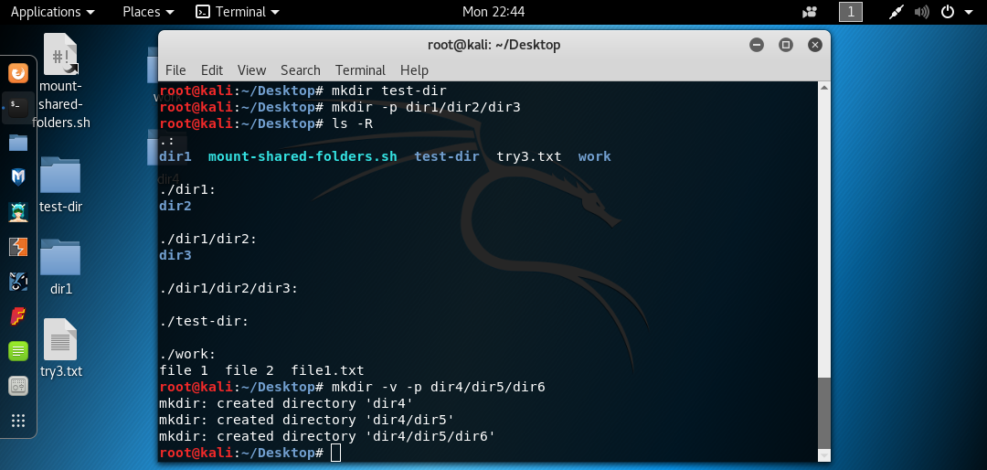

1. Rmdir

* Delete empty directories

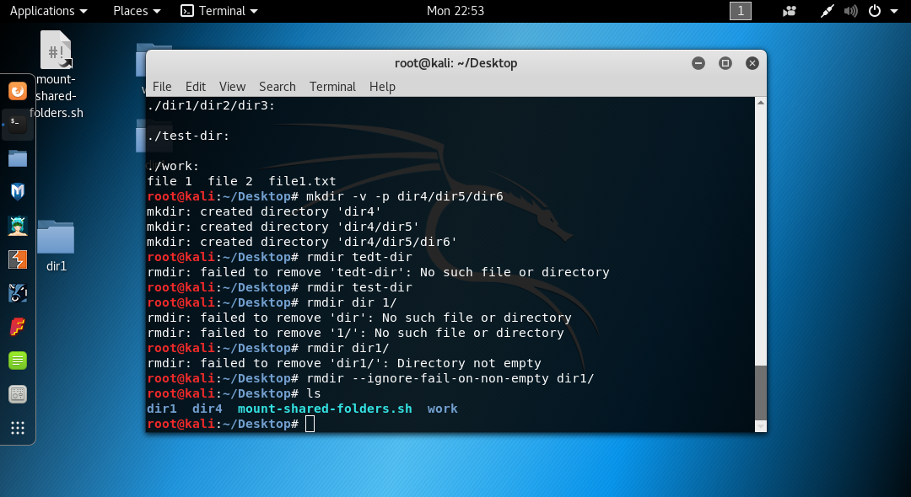

1. Rmdir - - ignore-fail-on-non-empty dir1/

* Ignore non- empty directories



1. Touch

* change file timestamps (the access and modification times). When name of a non-existent file is passed as an argument, that file gets created.

1. Touch work

* Change the file’s access and modification times.

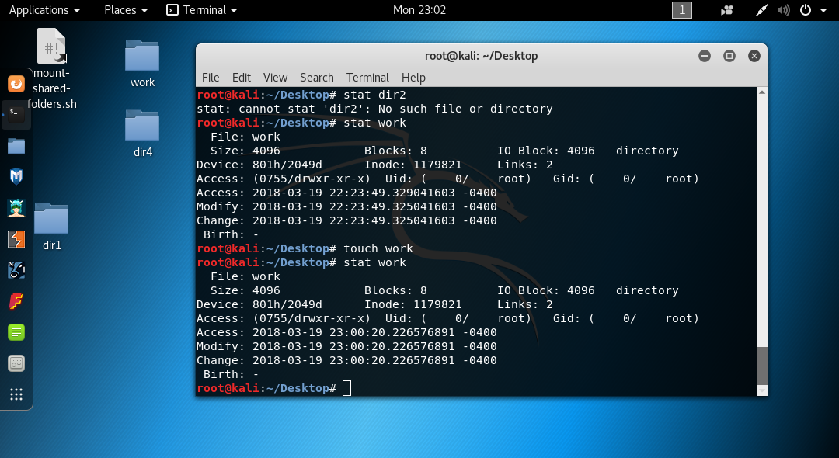

1. Touch -c newfile.txt

* Force touch to not create any new files.

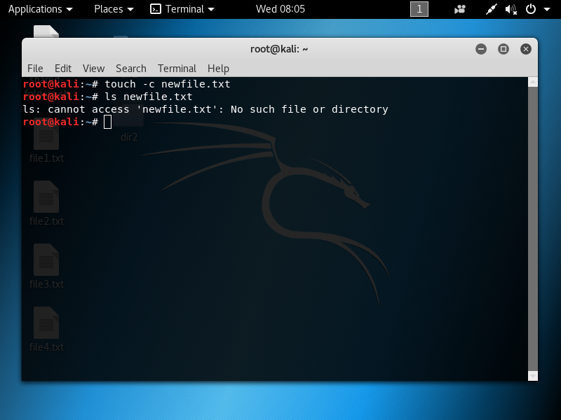

1. Cat

* To concatenate files, or data provided on standard input, and print it on the standard output.

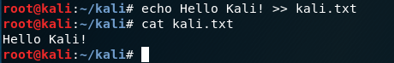

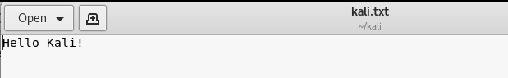

1. Pwd

* Display the name of current/working directories

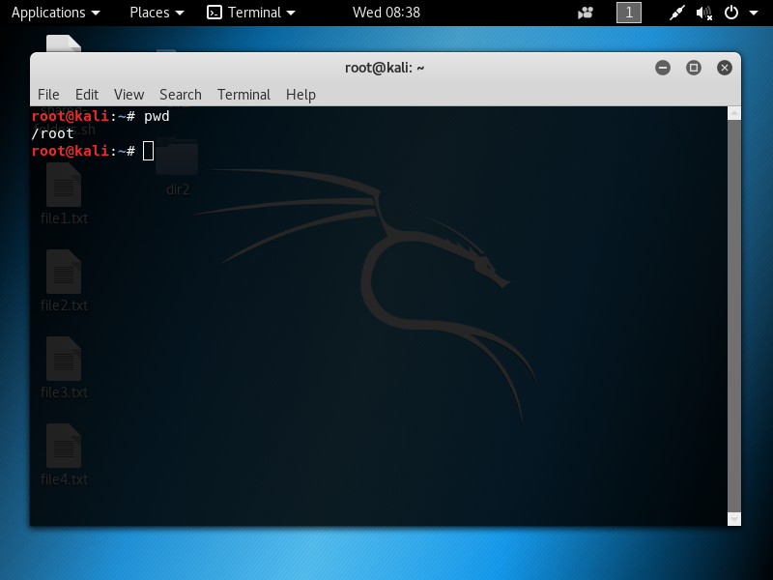

1. Ln

* Used for creating link between files

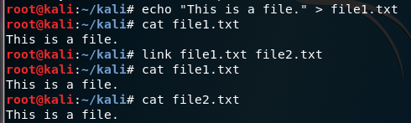

1. Chmod

* Change access permissions for a file

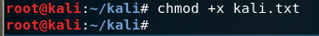

1. Chown

* Change the ownership and group of a file

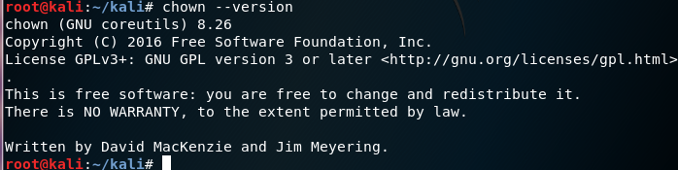

1. More

* View text files or other output in a scrollable manner. It displays the text one screenful at a time

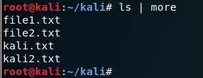

1. Less

* To view files instead of opening the file

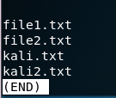

1. Grep

* Searches for a specified pattern in a file (or files) and displays in output lines containing that pattern.

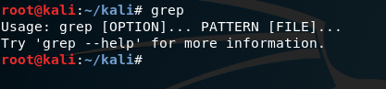

1. Wc

* Prints newline, word, and byte counts for a file.

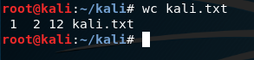

1. Kill

* Helps user kill a process by sending the TERM signal to it.

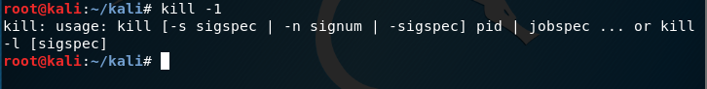

1. Ps

* Displays information (in the form of a snapshot) about the currently active processes.

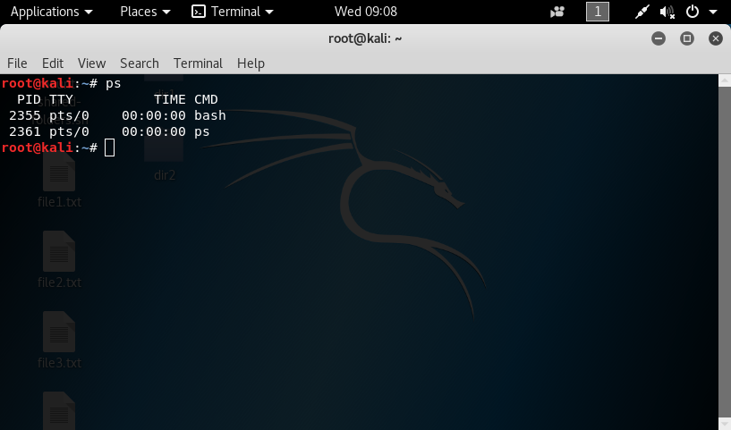

1. Top

* Gives  a dynamic real-time view of a running system (in terms of its processes)

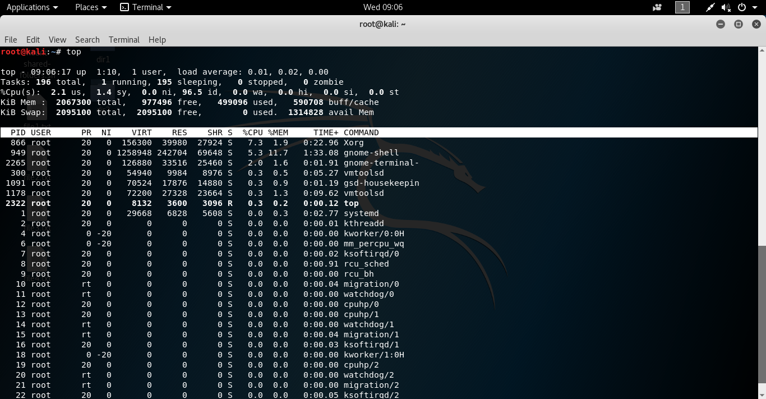

1. Uname

* Prints certain system information.

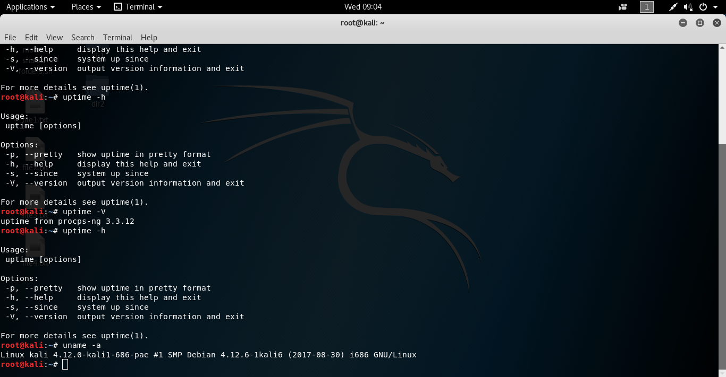

1. Uptime

* Tells how long the system has been running.

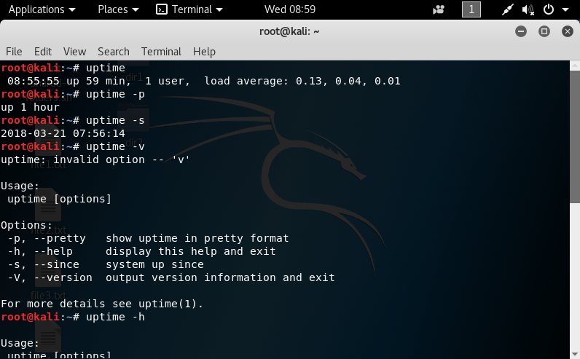

1. Uptime -p

* Show up time in pretty format



1. Uptime -V and Uptime -h

* To get version information and help in general

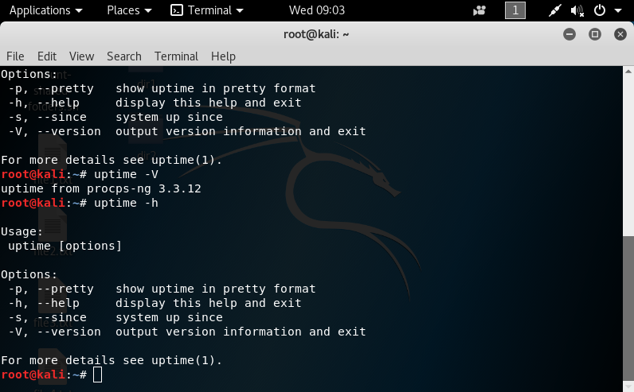

1. Ping

* to check whether or not a system is up and responding.

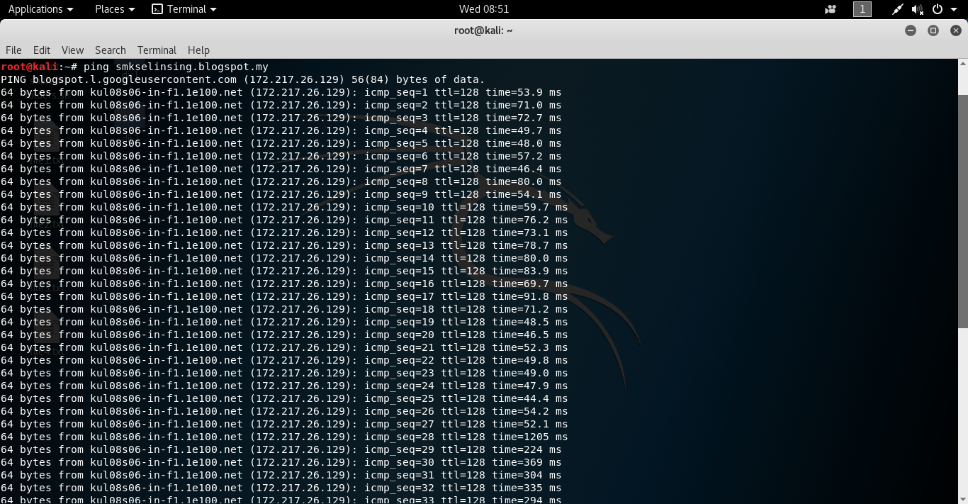

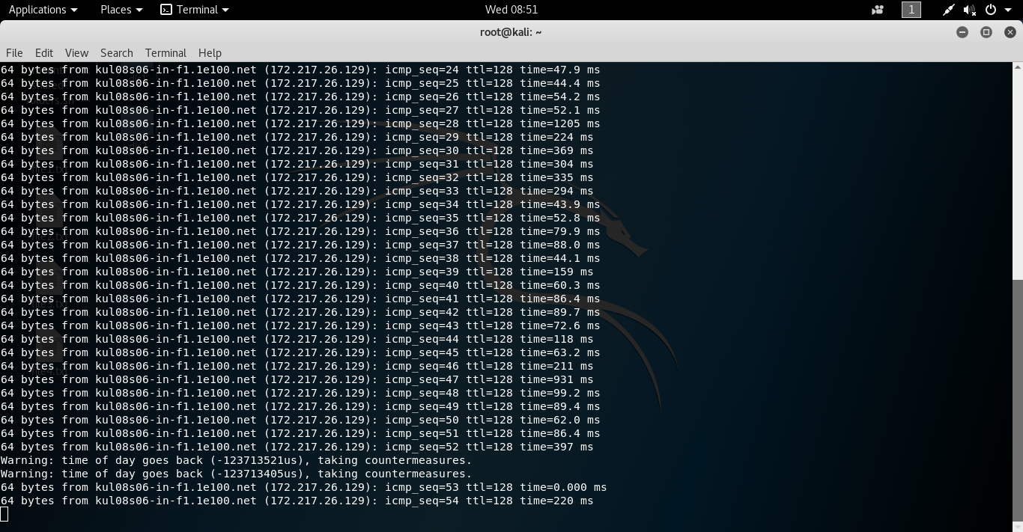

1. Nestat

* Listing all ports (both TCP and UDP) using **netstat** -a option.

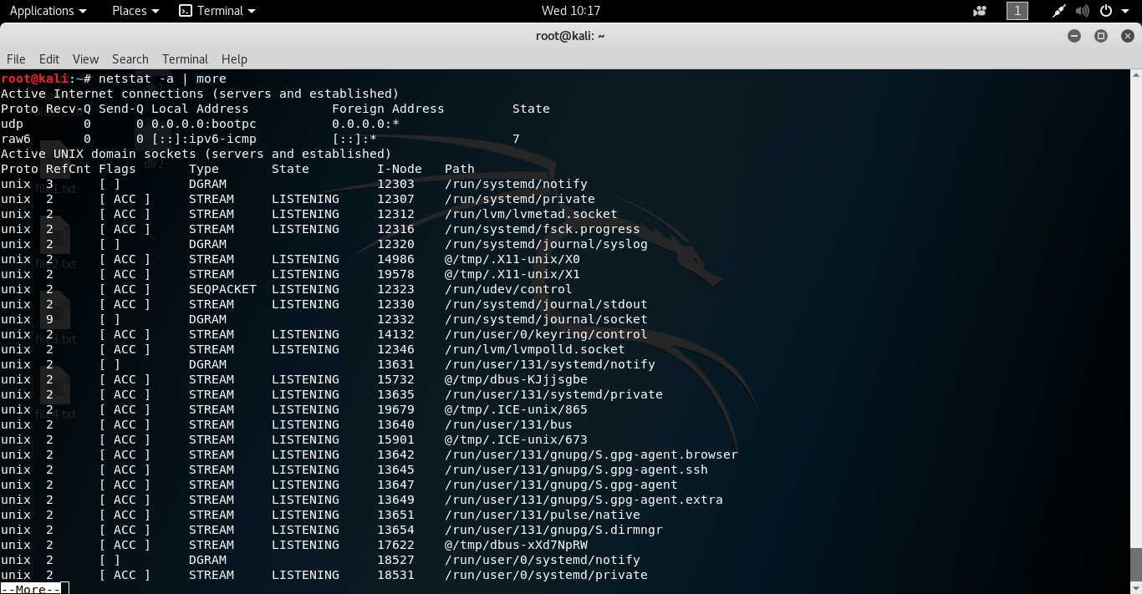

1. File

* Determines the file type of a file.

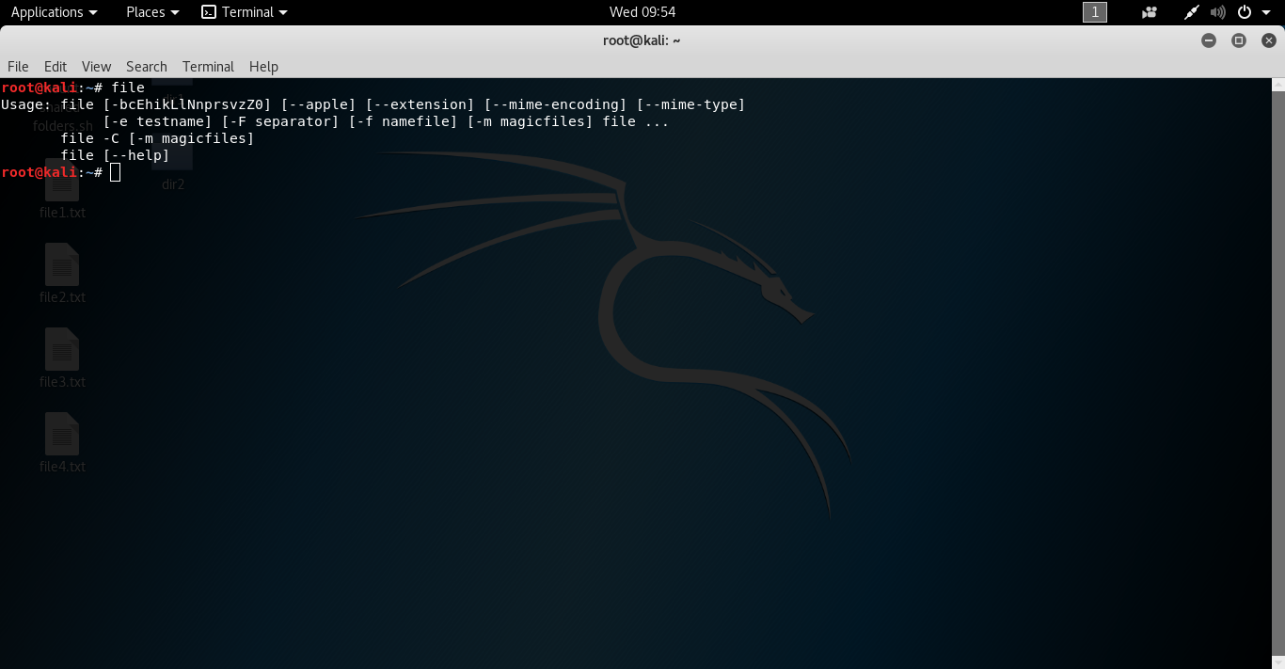

1. File -l

* Print information about the strength of each magic pattern.

